Design Patterns

What is good design?
We design for a purpose – that purpose determines whether a design is good.
Practicality, efficiency, maintainability, reusability, extensibility, flexibility, usability, learnability, beauty and elegance are all considerations for good design.

How do we share design knowledge?
A design pattern is:
- A description of a recurring solution (good or bad) for
  - a recurring design problem
  - in a certain context
The goal is to reuse the design information. Therefore, the pattern must not be ‘new’.
- A pattern writer must have an ‘aggressive disregard for originality’.
Patterns are well known in every engineering discipline, e.g.: mechanical, electrical, architecture.

History
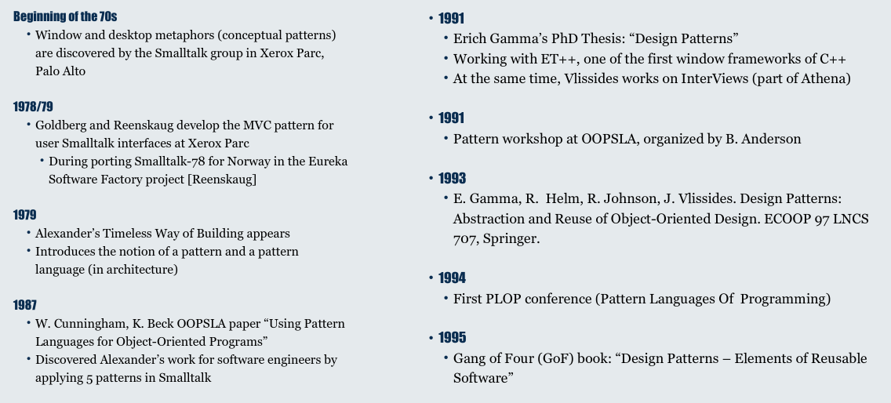

Structure of design patterns
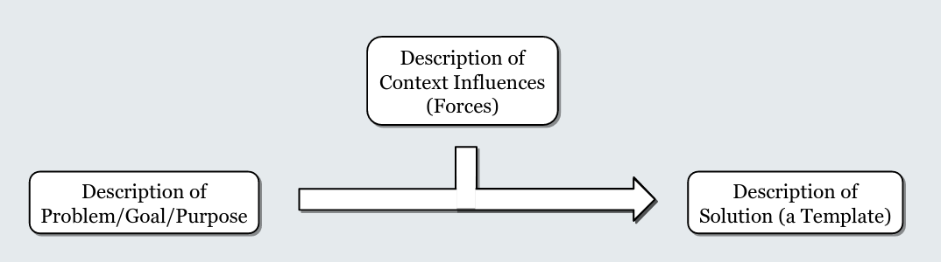

Design pattern template
- Name (incl. Synonyms)
- Intent
A short statement about the problem solved by the pattern
- Motivation
A concrete scenario illustrating the design problem and how it could be solved using the pattern
- Applicability
  - Situations when pattern can be applied
  - Examples of poor design that can be addressed by this pattern
  - How to recognise these situations
- Structure
Classes, abstract classes, relations: UML class or object diagram
- Participations
Description of behaviour with interaction diagrams
- Consequences
Advantages and disadvantages
- Implementation
Variants of the design pattern
- Code examples
- Known uses
Evidence that this is indeed a recurring pattern
- Related patterns
Patterns need to be combined with others to solve bigger design problems

What are Design Patterns good for?
Learning good design
- Through direct application of patterns
- By better understanding how patterns use the various tools of object orientation
Language of design
- Names for complex design structures
- Better communication in teams, e.g. “we can use a ‘singleton’ here”
- Understanding other people’s designs – “I can see an ‘observer’ here”
Improving existing designs
- “This looks like you could use a ‘Factory’, why aren’t you?”
- “You know that when using a ‘singleton’ you need to be careful to deal with concurrency, right?” - learn from other people’s mistakes, you don’t have time to make them all yourself.

Variability patterns
You need to write a generic algorithm, but allow some steps of the algorithm to be varied for different cases.
For example: algorithm for averaging a dataset.
- Load dataset
- Run through all the items and determine count and sum
- Compute average
The algorithm will vary depending on where the data comes from, e.g. DB, CSV.

Template method
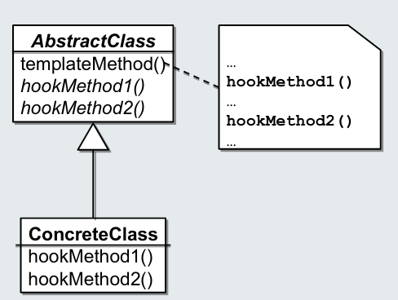
- Contains generic algorithm skeleton
- Delegates part of algorithm to abstract hook methods
- Hook methods are overwritten in sub-classes to provide the specific steps
- Template and hook method are implemented in the same (class/) object
- Uses polymorphism to enable variability

pros and cons
Pros:
- Easily provide core logic and variation points
- Easily provide many different implementations of the details and use the one you need
Cons:
- Variation supported only at compile time
- What about dynamic variability?

Strategy method – Method reification
What if we need to dynamically change the implementation in the hook methods?
- Allow users to choose data source at run time…
The template method can not do this as the implementation needs to be decided at development time and a suitable sub-class needs to be chosen. Afterwards, you cannot change anything.
The root problem:
- Variability is encapsulated in methods
- Methods cannot be dynamically changed
But we can change objects and object references dynamically
- So what if we changed the method into an object?
- Making a method or attribute its own object is called “Reification”
- The Strategy design pattern does just that.
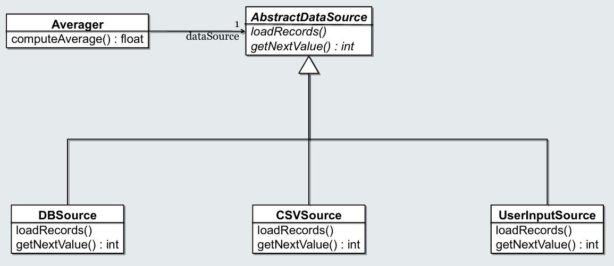
- Template method contains generic algorithm skeleton
- Delegates part of algorithm to strategy
- Hook methods are overwritten in sub-classes of strategy to provide the specific steps
- Template and hook method are implemented in different classes and objects
  - Can be exchanged at runtime
- Uses polymorphism to enable variability

Pros and cons
Pros
- Easily separate core logic and variation points
- Easily provide many different implementations of the details and use the one you need
- Functionality can be varied at system runtime
Cons
- Needs additional object i.e. “Object Schizophrenia”
  - this in the strategy object refers to the strategy object, but outside clients only know about the context. In the context object, this means the context object.
  - What if the strategy code needs to hand a pointer to the object to something outside the context? What should it pass?

Bridge strategy
- The behaviour of an object needs to change, possibly dynamically, but there are multiple orthogonal dimensions of variability
For example: change data source and how data is treated. However, you cannot simple use multiple parallel strategies as the different algorithms need to interact.
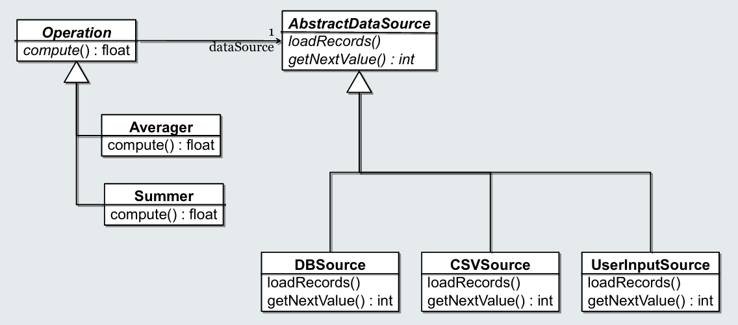

Pros and cons
Pros:
- Easily separate core logic
- Easily provide many different implementations of the details and use the one you need
- Support orthogonally varying different aspects of the behaviour – facets
- Functionality can be varied at system runtime
Cons:
- Object schizophrenia
- Fairly complex set up with logic distributed over quite a few classes
- Requires selecting correct classes to instantiate and ‘wire up’

Creational patterns
Consider a bridge pattern: What if there were dependencies between the different facets after all?

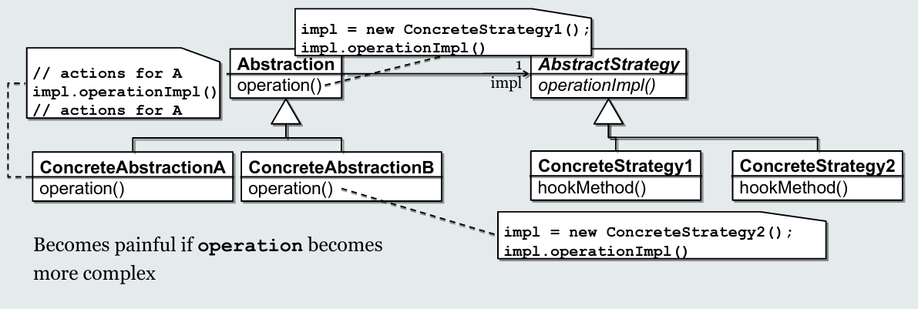
Factory method
Why not use Template Method to encapsulate the creation of the implementation?

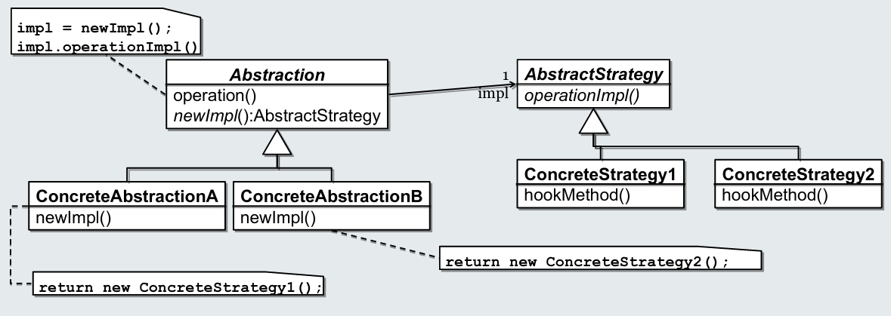
Pros and cons
Pros:
- Allows polymorphic creation of objects
- Nicely encapsulates object creation – client depends on abstraction not implementation
Cons:
- Creation is bound to containing class which contains other functionality
- Switching creation independently of other functionality is impossible.

Abstract factory
Whole set of classes for which we need to consistently switch out sub-classes
- Widgets in a window system (switch out presentation in one go)
- Cloud provider access objects (switch from one cloud provider to another, consistently replacing all types of services)
Need to bundle creation of objects of different sub-classes in one place
- So that switching becomes changing one line of code or replacing one object.
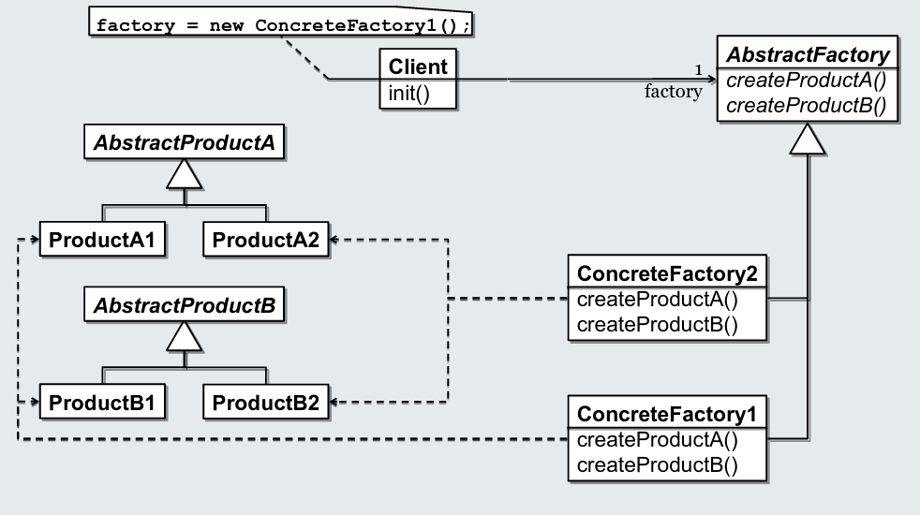
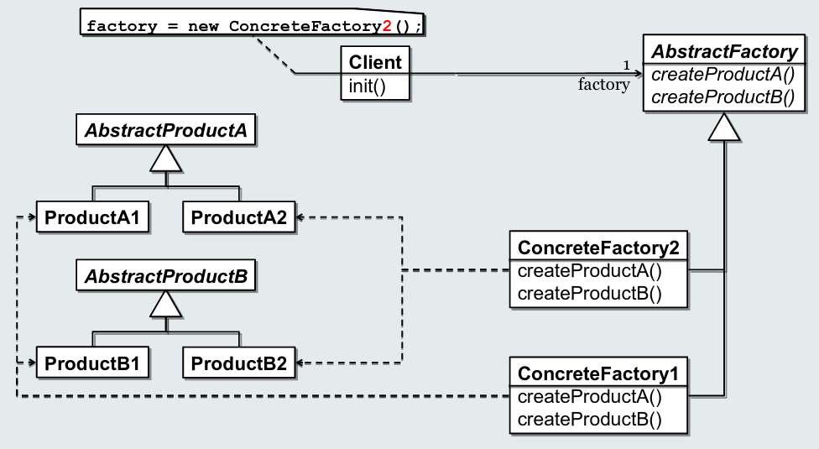

Pros and cons
Pros
- Allows polymorphic creation of objects
- Nicely encapsulates object creation – client depends on abstraction not implementation
- Groups creation logic for multiple inter-dependent classes
- Change one line of code to replace a set of classes, or even switch dynamically at run time
Cons
- Slightly more indirect code
- Only covers creation, what about other instantiation constraints? Even co-creation constraints like in Bridge/Factory method are no longer supported

Builder method
Ensure the correct construction of a complex object
For example: Construct a maze map for a text adventure game, ensuring all rooms have walls on each side, ensuring doors connect rooms in a consistent manner and ensuring objects are always placed in rooms.

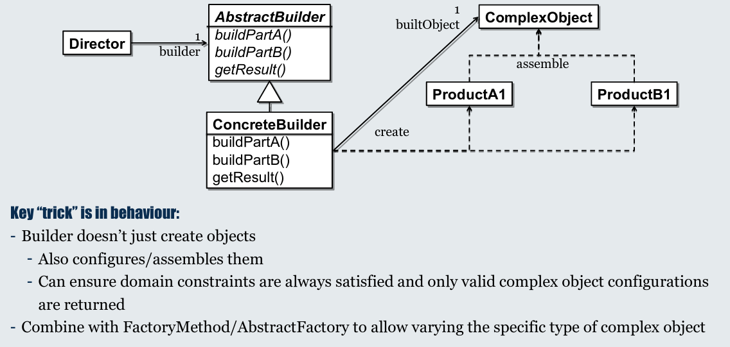
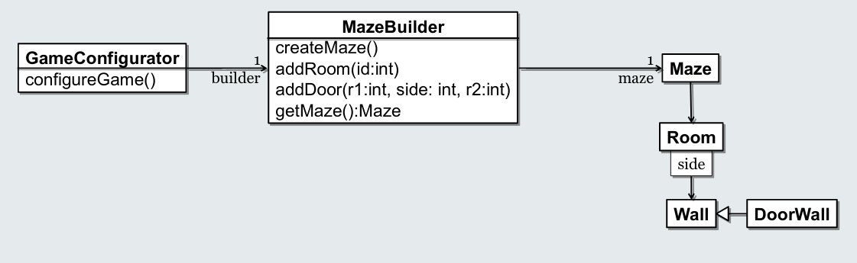
Pros and cons:
Pros
- Nicely encapsulates object configuration – constraints encapsulated and easily found in one place
- Groups construction logic for multiple inter-dependent classes
Cons
- More indirect code
- Needs to be combined with Factory pattern to enable easy switching of concrete implementations

Extensibility Patterns

Composite
A part-whole hierarchy should be represented so that clients can treat part and whole objects uniformly
- You need a tree-structured data structure, but client code shouldn’t need to worry about the complexity of any concrete tree being handled.
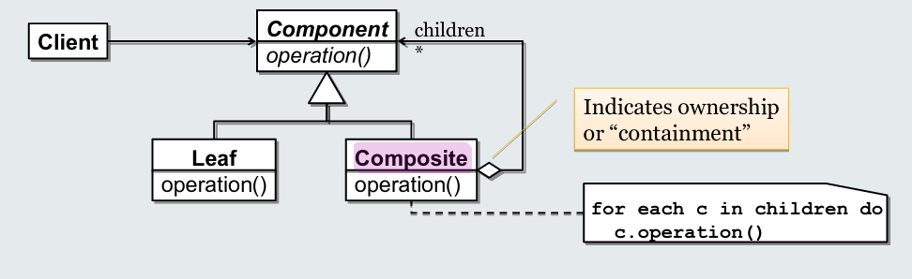

Pros and cons
Pros:
- Allows treating complex and simple objects in a homogeneous manner
Cons:
- Assumes there is a reasonably homogeneous interface for all elements of the graph. Where do you put operations for adding, removing and accessing children?
- Recursive operations are distributed all over the class hierarchy, which can make understanding classes more difficult and make extension more difficult.

Visitor
How can we flexibly add operations to a composite structure without loosing the benefits of the composite pattern?
For example: adding a “save” function to our shapes example, and a “validate” function.
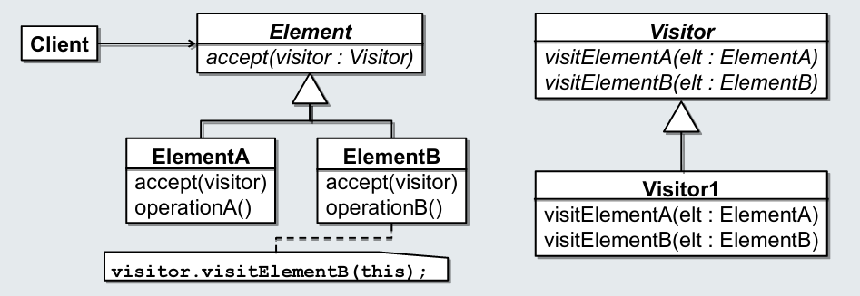
Key trick: “Double Dispatch”
- Method to call is decided by looking at run-time class of Element and at run time class of Visitor.
- Client can still call method without needing to know sub-type of Element

Pros and cons
Pros
- Easily add new operations to an existing class hierarchy without changing the classes themselves
  - Particularly good when the classes come from a library, so cannot be changed
- Keep all functionality for one purpose in one place
  - Rather than scattered across the structural classes
Cons
- Separates structure and behaviour
- Adding a new class means changing (and first finding) all visitors

Object recursion
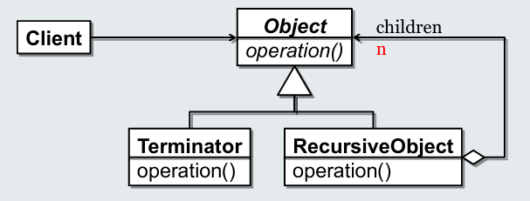

Key “trick”
- Recursion to abstract-superclass i.e. everything can be treated as an object and recursion over the structure is elegantly handled by polymorphism.
N could be 1 or *
- * gives Composite pattern with tree-related object graphs
- 1 produces list-shaped object graphs for a number of purposes
  - Decorator, Chain-of-Responsibility

Chain of responsibility
Often a request needs to be handled differently depending on different conditions, typically handled by large switch statement or long if-elsif-elsif-elsif… chains.
Neither are easily maintainable.
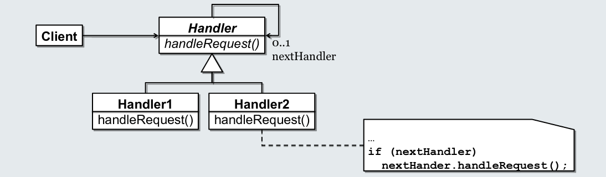
1-Recursion to abstract handler class
- Every handler can have 1 follower
- Handlers attempt to handle requests one at a time
- Once handled, can decide to hand to next handler or to stop
- Can adjust chain dynamically if needed

Pros and cons
Pros
- Each case is nicely encapsulated
- Possibility to dynamically adjust request handling as needed
- Can be declaratively configured
Cons
- Object structure must be set up explicitly with objects constructed at runtime, i.e. object proliferation

Decorator and adapter – “wrappers
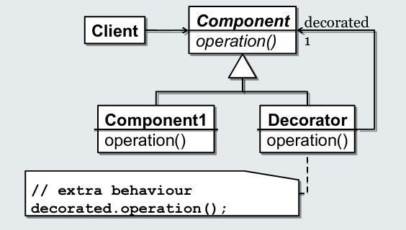

Decorator:
- Specialised chain allowing to add behaviour to an object “after the fact”
- For example, scrolling added as decoration to an arbitrary widget
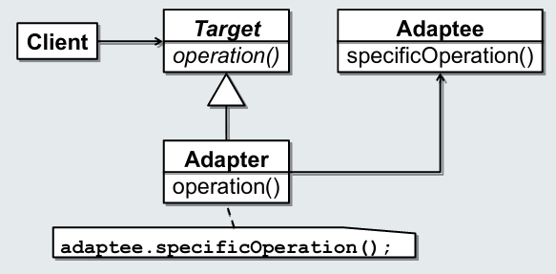

Adapter:
- Adjust interface of an object to new usage context

